**CN Lab Assignments: 11 -2- 2022**

( for odd roll numbers Q1, for even roll numbers Q2 )

**1. Nitw Rail Junction:** Consider the following different processes at Nitw Railway Junction as shown in figure below. Trains (T) may arrive at directional points H, V, D of the Station Master (SM). SM can accept a T if any of the Platform (P) is free. After accepting a T, the SM process gives (sends) the announcement of arrival of T to all the platforms. Then SM passes that train to a free platform (P) , so that the train (T) sends its sequence of compartments arrangement directly to platform (P). P displays the same. After the train leaves station, it informs the platform (P) that it has left. The platform process P notifies the same to SM.

Implement all the processes involved in this Railway Junction System Scenario.

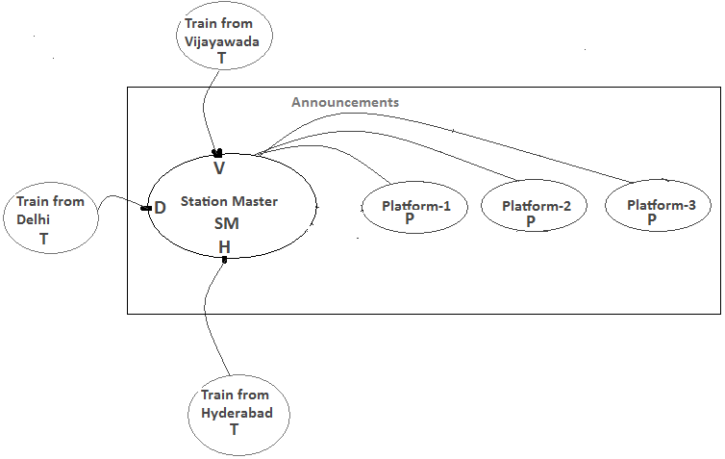

**2. Exclusive Special Server (ESS)-circular sharing:** Look at the following figure.

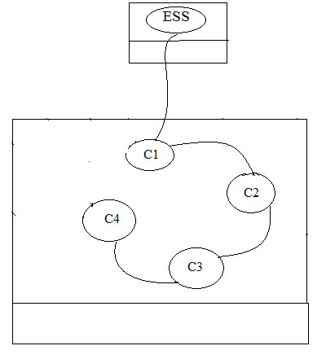

ESS is a very special server such that **only one of** the client processes running at a particular computer system can get served by it. Suppose, **unrelated** client processes of C1, C2, C3, C4 running at the **same computer** system wish to get served by ESS. The first client (say **C1**) **first gets connected** to ESS with **sfd.** Assume at the moment C1 is using the service of ESS though the connected sfd. As C2 wishes to use the service of ESS, it joins in the sharing. This joining will be known to C1. After some time, C1 **passes sfd to** C2 to use the service of ESS , and again after some time C2 may know C3(which has joined soon after C2) and C2 also **passes sfd to** C3 to use the service of ESS. After a while C3 may know C4 (which has joined soon after C3), and C4 in turn may transfer to C5, and so on as shown in figure. Any new client process can join in the circle of sharing at the rear or all the clients may be running at the same time and whenever they wish to use ESS they join in the queue.

Hint: All the clients have agreed to share and have made some arrangement and with agreed data formats.

Note that a Cj won’t be created by a Ci. They share service of ESS by passing sfd among themselves.